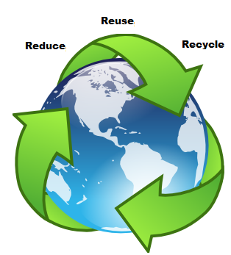

A Green Light to freshness!

ITW Insulated Products is helping to improve our environment by purchasing recycled products and recycling what we use at our facility.

Learn how reducing, reusing, and recycling can help you, your community, and the environment by saving money, energy and natural resources.

What Makes a Product Recycled?
Recycled products are products made from materials recovered or separated from the "waste stream," melted down or ground up into raw materials, and then used to make new products.
Recycled content can be:
Pre-consumer: From the manufacturing process, like scraps left over when envelopes are cut from paper.
Post-consumer: From a product that’s already been used, like newspapers, shipping cartons, plastic bottles, glass containers, and metal cans.
- REMEMBER TO ALWAYS:
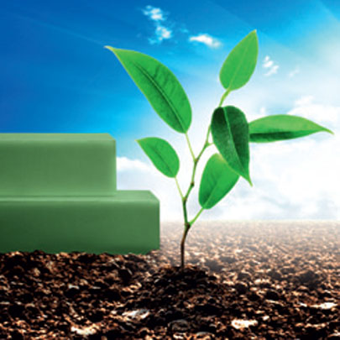
- Collect Recyclable materials form the waste stream
- Process the commodities into new products
- Purchase products containing recycled material

ITW Insulated Products’ employees have been working hard to step-up recycling efforts by evaluating and documenting our company’s waste. Employee’s insights and suggestions have been the key to recognizing items such as plastic, paper, cardboard, pallets, toner cartridges, steel, and aluminum that are candidates for recycling. We even took it one step further to ensure that as a company, we are doing our part by purchasing partially recycled materials to build some of our Insulated Bulkheads. (See Products for details) We are continually striving to purchase and process items that have been recycled or can be recycled.



